Op-Amp Gain Lab
Seth Ricks
ECEN 350
Brother Swenson

ECEN 350 – Op-Amp Gain Lab (60 points)
(jas, Op-Amp Gain Lab.docx, 10/24 /2024)

Note: You can work in pairs if desired on this lab, although no three person teams are allowed. Submit an electronic version of a lab report to receive credit for doing this lab. The goal of your lab report is to provide sufficient documentation so that the lab can be repeated if necessary. Therefore, simply add to this document to arrive at your lab report, as all of the explanatory text, procedures, and Discussion and Conclusion questions contained in this document are required for a complete lab report. So, for your lab report, add a cover page that includes name or names, class and name of the lab. Also add in your results, and answers to the Discussion and Conclusions questions to the existing lab document. While you are to share all Procedure items with your lab partner if you worked in a pair, your Discussion and Conclusions section is to be uniquely yours and not a copy of your lab partners. See the grading rubric at the end of this document for more details.

Purpose: To analyze and construct a voltage follower, inverting and non-inverting operational amplifier circuits to better understand the utility of op-amps.

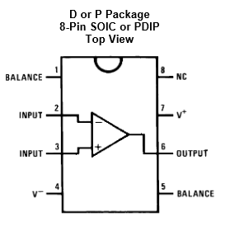
Parts and Equipment:
1 – LF356 Op-amp
1 – 0.1 µF Capacitor
1 – 100 Ω resistor
1 – 1.0 kΩ resistors
1 – 2.0 kΩ resistor
1 – 10 kΩ resistor
1 – 18 kΩ resistor
1 - 10 MΩ Resistor
1 – Portable Digital Multimeter (DMM)
1 - VirtualBench Measurement System and Computer.
2 - 1X/10X Probes for the VirtualBench MSO.
1 – BNC to alligator or micro-grabber cable for VirtualBench FGEN output.
1 - Breadboard.
Figure 1: Pin-out for LF356 Op-Amp.
Procedure:

Part 1 – Voltage Follower Application.

On rare occasions when breadboarding op-amps and other integrated circuits in Dual In-Line packages (DIPs), not all leads make good electrical contact with the metal connectors underneath the rows in the breadboard. Consequently, when debugging a breadboarded op-amp circuit it is recommended to check continuity between the pins of the DIP and the corresponding rows in the breadboard.

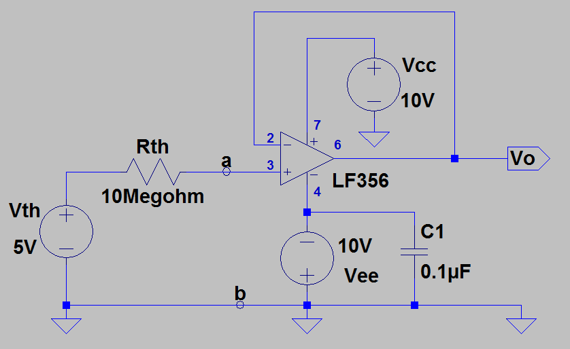
- Connect up the voltage follower configuration illustrated below in Figure 2. The Thevenin equivalent circuit in Figure 2 providing the input voltage to the voltage follower was previously used in the DMM Measurement Details Lab and Oscilloscope Lab to emphasize the difficulty of accurate voltage measurements in a circuit having a large Thevenin resistance. The LF356 op-amp configured as a voltage follower provides an effective means to alleviate this measurement problem. In this application the LF356 op-amp configured as a voltage follower is referred to as a buffer amplifier.
Use the VirtualBench adjustable +25 V supply set to 10.0 V for the V_{cc} supply and the adjustable -25 V supply set to -10.0 V for the V_{ee} supply. Use the VirtualBench adjustable +6 V supply set to 5.0 V for the V_{th} supply. Include a 0.1 µF decoupling capacitor C1 connected between adjacent V_{ee} and ground connection strips.
Figure 2: Voltage Follower Configuration.

- Configure the VirtualBench DMM to measure DC voltage on the 10 V input range and portable DMM to measure DC voltage on the 20 V input range. (Note: Both DMMs have a default input impedance of 10 MΩ when measuring DC voltages.)
- Referring to Figure 2, connect the VirtualBench DMM to measure the voltage between the a and b terminals, and the portable DMM to measure the voltage from V_{O} to ground.
- Record the resulting measured voltage below including units.
V_{ab}_Meas = 2.39 V (2 points.)

V_{O}_Meas_1 = 2.42 V (2 points.)

- Next disconnect the VirtualBench DMM from the a and b terminals illustrated in Figure 2, and record the resulting output voltage, including units, measured by the Portable DMM. (Note: Your V_{O}_Meas_2 voltage value in step 5 should be approximately two times larger than your V_{O}_Meas_1 voltage value from step 4, else there is a set-up problem.)
V_{O}_Meas_2 = 4.98 V (2 points.)

- Turn off the VirtualBench Power Supplies and remove the adjustable +6 V supply from the circuit, to be replaced with the VirtualBench FGEN output for part 2.

Part 2 – Non-Inverting Amplifier Configuration.

- Connect up the non-inverting amplifier configuration illustrated in Figure 3. Resistor R3 is included simply to help protect the plus (+) input of the LF356 from possible static discharges when connecting and removing FGEN and oscilloscope leads on the V_{i} input. R3 has no influence on the voltage gain or input impedance of this non-inverting amplifier.

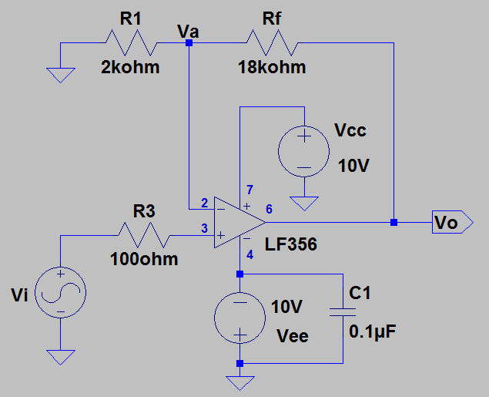
Use the VirtualBench adjustable +25 V supply set to 10.0 V for the V_{cc} supply and the adjustable -25 V supply set to -10.0 V for the V_{ee} supply. Again, include a 0.1 µF decoupling capacitor C1 connected between adjacent V_{ee} and ground connection strips.

Figure 3: Non-Inverting Amplifier Configuration to be Characterized.

- Connect the oscilloscope probe with the red marking bands to Channel 1 (CH 1) and the oscilloscope probe with the yellow marking bands to Channel 2 (CH 2) on the VirtualBench CH 1 and CH 2 oscilloscope BNC connectors. Make sure the slide switches at the probe tip end of the oscilloscope probes are set to 10X versus 1X.
- Make sure that both the CH 1 and CH 2 are set for AC coupling and 10X probe attenuation.
- Set the VirtualBench Function Generator to output a 250 mV peak-to-peak sine wave with zero DC offset voltage, and connect the BNC to alligator or micro-grabber cable so as to provide the voltage V_{i} input indicated in Figure 3.
- Connect up oscilloscope, with CH 1 to monitor V_{o} and oscilloscope CH 2 to monitor V_{i} for the Figure 3 circuit, with the larger V_{o} signal as the oscilloscope trigger source.
- Using the VirtualBench built-in oscilloscope waveform measurements, add a Peak-to-Peak Waveform Measurement to CH 1.
- The oscilloscope’s automatic peak-to-peak measurement function does not work well on relatively small signals because of noise, and so use the waveform cursors instead to measure the CH 2 peak-to-peak voltage V_{i}. To do so set the cursor type as Voltage and position the two waveform cursors to provide a voltage difference, i.e., ∆Y, that represents the average peak-to-peak voltage of the signal at V_{i} in Figure 3. Record this cursor measured peak-to-peak value as V_{i} (pk-pk) in Table 1 below, adjusting the cursors as necessary for the different input frequencies. Also, for each input frequency listed in Table 1 below, record the CH 1 Peak-to-Peak Waveform Measurement as V_{o} (pk-pk) in the table.
- Complete Table 1 below with measured and calculated values for each of the input frequencies listed, adjusting the frequency of the FGEN output accordingly. Be sure to include units for V_{i} and V_{o}, either by adding them once to each column label at the top or to each measured value. While the voltage ratio V_{o}/V_{i} is dimensionless, the dB $magnitude is defined as follows {\left|A_{v}\right|}_{dB} =20\log_{10}\left(\left|{V_{o}}/{V_{i}}\right|\right)$. (8 points total.)

Table 1: Measured Data for the Non-Inverting Amplifier Configuration.
Input Frequency | V_{i}  (pk-pk) | V_{o}  (pk-pk) | |Av| = |V_{o}/V_{i} | | ${\left|A_{v}\right|}_{dB}$¹
10 Hz | 254 mV | 2.47 V | 9.72 | 19.76
100 Hz | 254 mV | 2.51 V | 9.88 | 19.90
1 kHz | 254 mV | 2.51 V | 9.88 | 19.90
10 kHz | 254 mV | 2.47 V | 9.72 | 19.76
30 kHz | 254 mV | 2.47 V | 9.72 | 19.76
100 kHz | 254 mV | 2.39 V | 9.41 | 19.47
300 kHz | 254 mV | 2.14 V | 8.43 | 18.51
1 MHz | 254 mV | 1.19 V | 4.69 | 13.41
1 – $Voltage Gain Magnitude {\left|A_{v}\right|}_{dB}=20\log_{10}\left(\left|{V_{o}}/{V_{i}}\right|\right)$.

- Based on your Table 1 data, plot the magnitude in dB on the vertical axis versus frequency on the horizontal axis, using a logarithmic scale for the frequency, which is a Bode magnitude plot. The MATLAB semilogx() plot command can be used to provide the logarithmic frequency axis scale if you choose to use MATLAB. Include appropriate horizontal and vertical axis labels with units along with the title “Gain Magnitude versus Frequency of A Non-Inverting Op-Amp Configuration – Your Name or Names”. Replace the plot below with your version, keeping the figure number and caption. (6 points.)

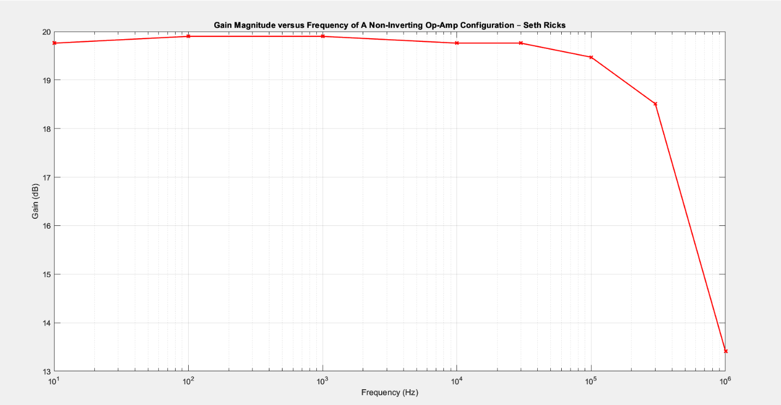
Figure 4: Frequency Response of the Non-Inverting Op-Amp Configuration of Figure 3.

Part 3 – Inverting Amplifier Configuration

- Connect up the inverting amplifier configuration illustrated in Figure 5.

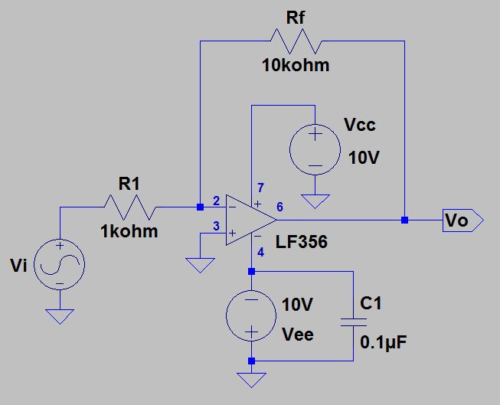
Use the VirtualBench adjustable +25 V supply set to 10.0 V for the V_{CC} supply and the adjustable -25 V supply set to -10.0 V for the V_{ee} supply. These supplies share a common ground with the adjustable +25 V supply output voltage being ≥ 0 V and the adjustable -25 V supply output voltage being ≤ 0 V. The negative supply has switching noise on it that can be problematic for higher speed op-amps, like the LF356. Consequently, a 0.1 µF decoupling capacitor C1, as shown in Figure 5, is to be included to help shunt the switching noise from V_{ee} to ground. A pair of the long power supply rail connection strips available on breadboards is recommended for V_{ee} and ground for this lab, with decoupling capacitor C1 connected between adjacent connection strips.

Figure 5: Inverting Amplifier Configuration to be Characterized.

- Connect the oscilloscope probe with the red marking bands to Channel 1 (CH 1) and the oscilloscope probe with the yellow marking bands to Channel 2 (CH 2) on the VirtualBench CH 1 and CH 2 oscilloscope BNC connectors. Make sure the slide switches at the probe tip end of the oscilloscope probes are set to 10X versus 1X.
- Start up the VirtualBench user interface software and for the CH 1 and CH 2 settings make sure that both are set for AC coupling and 10X probe attenuation.
- Set the VirtualBench Function Generator to output a 250 mV peak-to-peak sine wave with zero DC offset voltage, and connect the BNC to alligator or micro-grabber cable so as to provide the voltage V_{i} input indicated in Figure 5.
- Connect up two channels on the oscilloscope, with CH 1 to monitor V_{o} and CH 2 to monitor V_{i} for the Figure 5 circuit, with the larger V_{o} signal as the oscilloscope trigger source.
- Using the VirtualBench built-in oscilloscope waveform measurements, add a Peak-to-Peak Waveform Measurement to CH 1.
- The oscilloscope’s automatic peak-to-peak measurement function does not work well on relatively small signals because of noise, and so use the waveform cursors instead to measure the CH 2 peak-to-peak voltage V_{i}. To do so set the cursor type as Voltage and position the two waveform cursors to provide a voltage difference, i.e., ∆Y, that represents the average peak-to-peak voltage of the signal at V_{i} in Figure 5. Record this cursor measured peak-to-peak value as V_{i} (pk-pk) in Table 2 below, adjusting the cursors as necessary for the different input frequencies. Also, for each input frequency listed in Table 2 below, record the CH 1 Peak-to-Peak Waveform Measurement as V_{o} (pk-pk) in the table.
- Complete Table 2 below with measured and calculated values for each of the input frequencies listed, adjusting the frequency of the FGEN output accordingly. Be sure to include units for V_{i} and V_{o}, either by adding them to the column label or to each value. While the voltage ratio V_{o}/V_{i} is dimensionless, the dB magnitude is defined as follows: ${\left|A_{v}\right|}_{dB} =20\log_{10}\left(\left|{V_{o}}/{V_{i}}\right|\right)$. (8 points total.)

Table 2: Measured Data for the Inverting Amplifier Configuration.
Input Frequency | V_{i}  (pk-pk) | V_{o}  (pk-pk) | |Av| = |V_{o}/V_{i} | | ${\left|A_{v}\right|}_{dB}$¹
10 Hz | 254 mV | 2.35 V | 9.25 | 19.32
100 Hz | 254 mV | 2.39 V | 9.41 | 19.47
1 kHz | 254 mV | 2.39 V | 9.41 | 19.47
10 kHz | 254 mV | 2.39 V | 9.41 | 19.47
30 kHz | 254 mV | 2.39 V | 9.41 | 19.47
100 kHz | 254 mV | 2.30 V | 9.06 | 19.14
300 kHz | 254 mV | 2.02 V | 7.95 | 18.01
1 MHz | 254 mV | 1.11 V | 4.37 | 12.81
1– $Voltage Gain Magnitude {\left|A_{v}\right|}_{dB}=20\log_{10}\left(\left|{V_{o}}/{V_{i}}\right|\right)$

- Based on your Table 2 data, plot the magnitude in dB on the vertical axis versus frequency on the horizontal axis, using a logarithmic scale for the frequency, which is a Bode magnitude plot. The MATLAB semilogx() plot command can be used to provide the logarithmic frequency axis scale if you choose to use MATLAB. Include appropriate horizontal and vertical axis labels with units along with the title “Gain Magnitude versus Frequency of An Inverting Op-Amp Configuration – Your Name or Names”. Replace the plot below with your version, keeping the figure number and caption. (6 points.)

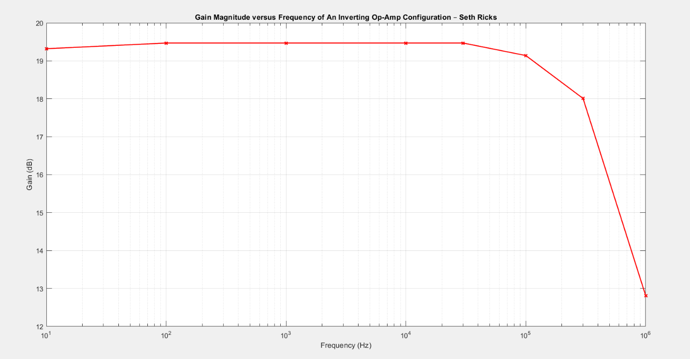
Figure 6: Frequency Response of the Inverting Op-Amp Configuration of Figure 5.

Discussion and Conclusions Questions: (For the following questions use your own words along with complete sentences. Points are to be deducted for AI generated answers.)

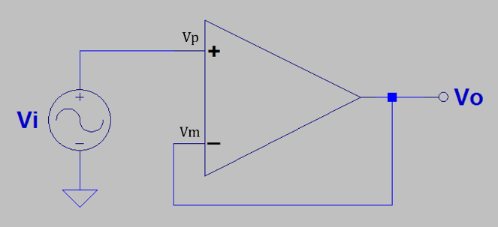
- Explain how an ideal op-amp in the adjacent voltage follower configuration results in the voltage V_{o} to equal the voltage V_{i}. Include mention of open-loop gain, along with the type of feedback used. (5 points.)

In an ideal op amp, the negative terminal will follow the positive terminal. In other words, V_{p} and V_{m} are the same in the above circuit. Because Vi is directly fed into V_{p}, The voltage at V_{p} is equivalent to Vi. This means that V_{m} must also be equal to V_{p}. Because V_{o} is also directly connected to V_{m}, V_{m} is equal to V_{o}. Connecting these all together,
$$V_{p}=V_{i}, V_{m}=V_{o}, V_{m}=V_{p}, so V_{o}=V_{i}$$

- Referring to Figure 2 from Part 1, explain why the measured voltage V_{O}_Meas_1 was significantly less than the Thevenin voltage of 5 V, illustrated in Figure 2. (4 points.)
The value for V_{o} was significantly less than the Thevenin voltage because of the impedance of 10 MΩ of the VirtualBench DMM at the input of the Op Amp. Because of this interference, the DMM noticeably pulls down the voltage into the Op amp. This is why the output voltage was less than 5 volts, because the voltage into the op amp was altered.

- Referring to Figure 2 from Part 1, explain why the measured voltage V_{O}_Meas_2 was essentially equal to the Thevenin voltage of 5 V. (4 points.)

Similar to my answer for question 2, when the VirtualBench DMM was removed from the input terminal of the Op Amp, so was the 10 MΩ impedance into the DMM. This meant that the input impedance was the same as the voltage source, which was 5 volts. Because of the nature of the feedback loop, the output voltage was also 5 V. Essentially once we removed the undesired input impedance, the circuit behaved as expected.

- Calculate the ideal closed-loop voltage gain ratio, i.e., the V_{o}/V_{i} ratio not in dB, of the non-inverting amplifier circuit illustrated in Figure 3, including your main steps and results below. (2 Points.)
$I_{R3}=0A$; $V_{p}=250mV$; $V_{a}=250mV$
$$I_{R1}=\frac{250mV-0}{2kΩ}=12.5 mA=I_{Rf}$$
$$V_{Rf}=\left(I_{Rf}\right)\left(R_{f}\right)=\left(12.5mA\right)\left(18kΩ\right)=2.25V$$
$$V_{Rf}=V_{o}-V_{a};V_{o}=V_{Rf}+V_{a}=2.25V+250mV=2.5V$$
$$\left|A_{v}\right|=\frac{V_{o}}{V_{i}}=\frac{2.5 V}{0.25 V}=10$$
$$\left|A_{v}\right|=10$$

- Calculate the ideal closed-loop voltage gain ratio, i.e., the V_{o}/V_{i} ratio not in dB, of the inverting amplifier circuit illustrated in Figure 5, including your main steps and results below. (2 Points.)
$$V_{R1}=250 mV$$
$$I_{R1}=\frac{250 mV}{1kΩ}=0.25 mA=I_{Rf}$$
$$V_{Rf}=\left(10 kΩ\right)\left(0.25 mA\right)=2.5 V$$
$$V_{o}=V_{Rf}=2.5 V$$
$$\left|A_{v}\right|=\frac{V_{o}}{V_{i}}=\frac{2.5 V}{0.25 V}=10$$
$$\left|A_{v}\right|=10$$

- Given the choice between the inverting or noninverting amplifier configurations used in this lab, using your own words and complete sentences explain which you would choose for an application requiring very high input impedance. (3 Points.)
Given the choice between the two, I would choose the non-inverting amplifier. This is because in the inverting amplifier, the input is directly connected to the output through R₁ and R_{f}. So ultimately it will have an input impedance of 11 $kΩ.$But with the non-inverting amplifier, the input is directly fed through the op amp. Because the op amp has a theoretical impedance of infinity, that means that the overall impedance will also be infinity. So, the non-inverting amplifier has a much higher input impedance than the inverting amplifier.

Op-Amp Gain Lab Grading Rubric: Submit an electronic version of a lab report to receive credit for doing this lab. The goal of your lab report is to provide sufficient documentation so that the lab can be repeated if necessary. Therefore, simply add to this document to arrive at your lab report, as all the explanatory text, procedures, and Discussion and Conclusion questions contained in this document are required for a complete lab report. So, for your lab report, add a cover page that includes name or names, class and name of the lab. Also add in your results, and answers to the Discussion and Conclusions questions to the existing lab document. While you are to share all Procedure items with your lab partner if you worked in a pair, your Discussion and Conclusions section is to be uniquely yours and not a copy of your lab partners.
Lab Report Item | Points
Cover Page | 2
Reasonable V_{ab}_Meas, V_{O}_Meas_1, and V_{O}_Meas_2 Values. (6 points total. -0.25 points for each missing unit.) | 6
Reasonable Table 1 data, including units for V_{i} and V_{o}. (8 points total. 0.25 points per entry, -0.1 points for each incorrect or missing unit. Units appearing at the top of column headings are fine.) | 8
Figure 4. (6 points total. 2 points for using a logarithmic frequency axis, 1 point for using dB magnitude data from Table 1, 1 point for x-axis label including units, 1 point for y-axis label including units, 1 point for title including name or names.) | 6
Reasonable Table 2 data, including units for V_{i} and V_{o}. (8 points total. 0.25 points per entry, -0.1 points for each incorrect or missing unit. Units appearing at the top of column headings are fine.) | 8
Figure 6. (6 points total. 2 points for using a logarithmic frequency axis, 1 point for using dB magnitude data from Table 1, 1 point for x-axis label including units, 1 point for y-axis label including units, 1 point for title including name or names.) | 6
Discussion and Conclusions | 20
Grammar and Professionalism | 4
Total | 60

Please give feedback on errors you find in this document.

